Name: ____________________________ Surname: ____________________________ N^{ber}: ____ Grade/Class: _____
Assessment: _____________________________ | Date: ___________________________________________________
 | Teacher’s signature:  ___________________________ | Parent’s signature:  ___________________________

Look, read and write.

rs
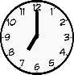
Hi, my name’s Peter and I’m ten years old.
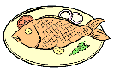
I have dinner at seven o’clock.
I like fish and chips.
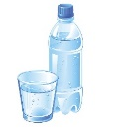
I don’t like soup.
Peter - 10
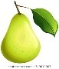
My favourite drink is water
And my favourite fruit is pears.

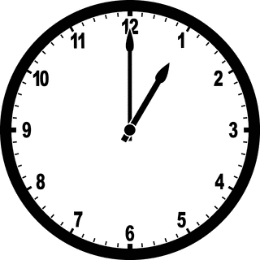
Hi, _____________________________________
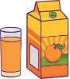
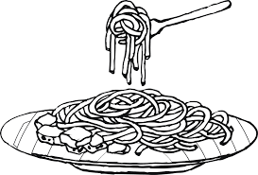
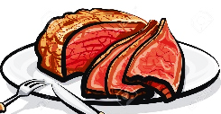
__________________________________
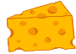
____________________________
__________________________________
Sally - 9
______________________________
______________________________

