Name: ____________________________ Surname: ____________________________ N^{ber}: ____ Grade/Class: _____
Assessment: _____________________________ | Date: ___________________________________________________
 | Teacher’s signature:  ___________________________ | Parent’s signature:  ___________________________
Reorder the questions and answer.
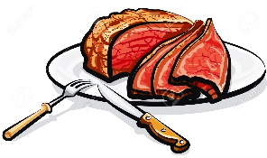
he / like / does /
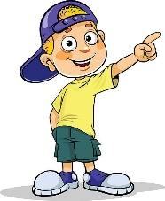
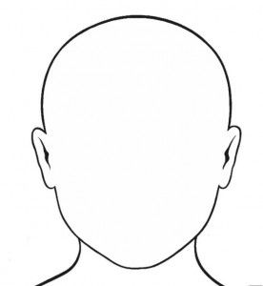
a)
___________________________?
_____ , ___ _______

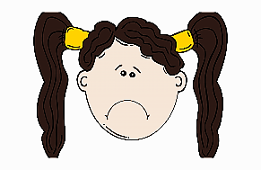
like / does / she /
___________________________?
she / like / does /
b)
_____ , ___ _______

_____ , ___ _______

c)
___________________________?

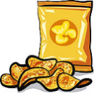
does / like / he /
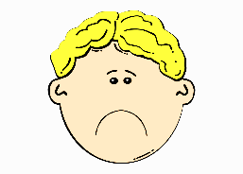
d)
___________________________?
_____ , ___ _______

e)
do / like / you /
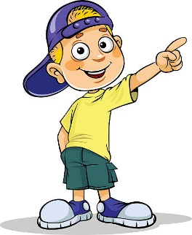
_____ , ___ _______

___________________________?

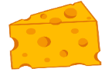
you / do / like /
Me
_____ , ___ _______

___________________________?

ANSWER KEY

- Does he like meat? Yes, he does.
- Does she like eggs? No, she doesn’t.
- Does she like tea? Yes, she does.
- Does he like crisps? No, he doesn’t.

- Do you like hamburger? Yes, I do. / No, I don’t.
Do you like cheese? Yes, I do. / No, I don’t.

