Name: ____________________________ Surname: ____________________________ N^{ber}: ____ Grade/Class: _____
Assessment: _____________________________ | Date: ___________________________________________________
 | Teacher’s signature:  ___________________________ | Parent’s signature:  ___________________________

1) Look and write what they like and don’t’ like.
likes / doesn’t like * like / don’t like

a)
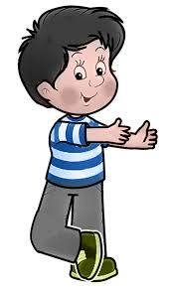
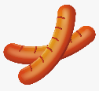  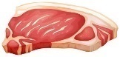 | 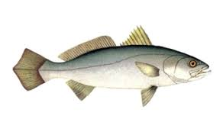

Peter ______________ m_ _ _ and s_ _ _ _ _ _ _ but he ____________ f_ _ _ or e_ _ _

b)
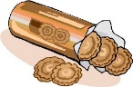  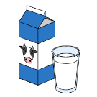 | 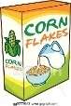

Emma ______________ m_ _ _ and b_ _ _ _ _ _ _ but she ____________ y_ _ _ _ _ or c_ _ _ _ _

2) And you?
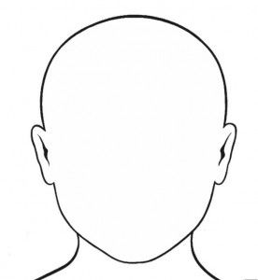
I ____________ _______________ and ______________ but
I _____________ _______________ or ________________.

This is me
ANSWER KEY
1)
- Peter likes meat and sausages but he doesn’t like fish or eggs.
- Emma likes milk and biscuits but she doesn’t like yogurt or cereal.
- She likes milk and biscuits.
- He doesn’t like chips or fish.
2)
I like… and … but I don’t like… or…

