Name: ____________________________ Surname: ____________________________ N^{ber}: ____ Grade/Class: _____
Assessment: _____________________________ | Date: ___________________________________________________
 | Teacher’s signature:  ___________________________ | Parent’s signature:  ___________________________

1) Look and write what they like or dislike.
He / She * likes / doesn’t like
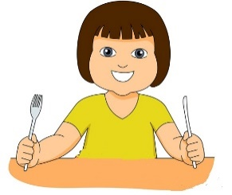
a)

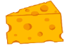
_______ ___________________ h_ _ b _ _ g _ _ and c_ _ _ s _.

b)

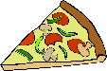
_______ ___________________ l_ m _ _ _ de or p_ _ _ a.

c)
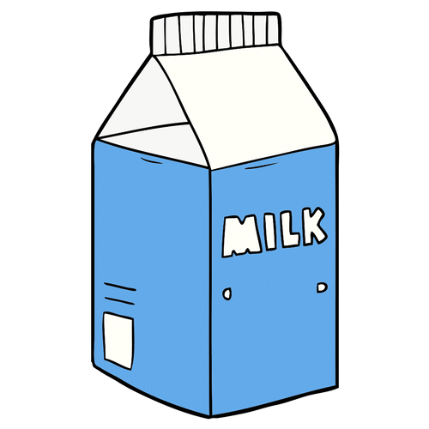
_______ ___________________ m_ l _ and b_ _ c _ _ t s.

d)
_______ ___________________ c_ _ p _ or f_ _ h.

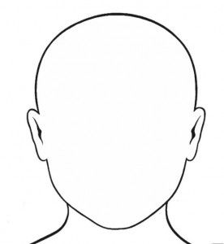
2) And you?
I ___________ ______________ and ______________

I ___________ ______________ or ______________
This is me
ANSWER KEY
1)
- She likes hamburger and cheese.
- He doesn’t like lemonade or pizza.
- She likes milk and biscuits.
- He doesn’t like chips or fish.
2)
I like… and …
I don’t like… or…

