Name: ____________________________ Surname: ____________________________ N^{ber}: ____ Grade/Class: _____
Assessment: _____________________________ | Date: ___________________________________________________
 | Teacher’s signature:  ___________________________ | Parent’s signature:  ___________________________

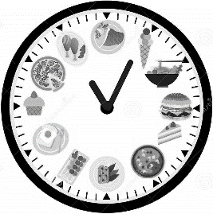
Write about the different meals you have during the day.
- Meals;
- Time and part of the day;
- What you like.

B r s
e k a
a f t
I have _ _ _ _ _ _ _ _ _ at ________________________________ in the m________________.
I ________ ____________________________ and ________________________ for breakfast.
c u
L h n
I have _ _ _ _ _ at ________________________________ in the a________________.
I ____________________________________________________________________________
S a
c k n
___________________________________________________________________________
___________________________________________________________________________
i n e
D r n
___________________________________________________________________________
___________________________________________________________________________

