Name: ____________________________ Surname: ____________________________ N^{ber}: ____ Grade/Class: _____
Assessment: _____________________________ | Date: ___________________________________________________
 | Teacher’s signature:  ___________________________ | Parent’s signature:  ___________________________

Listen and colour.

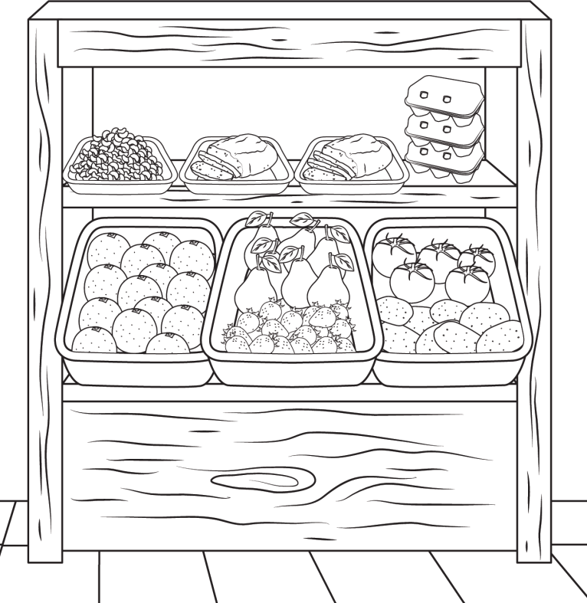
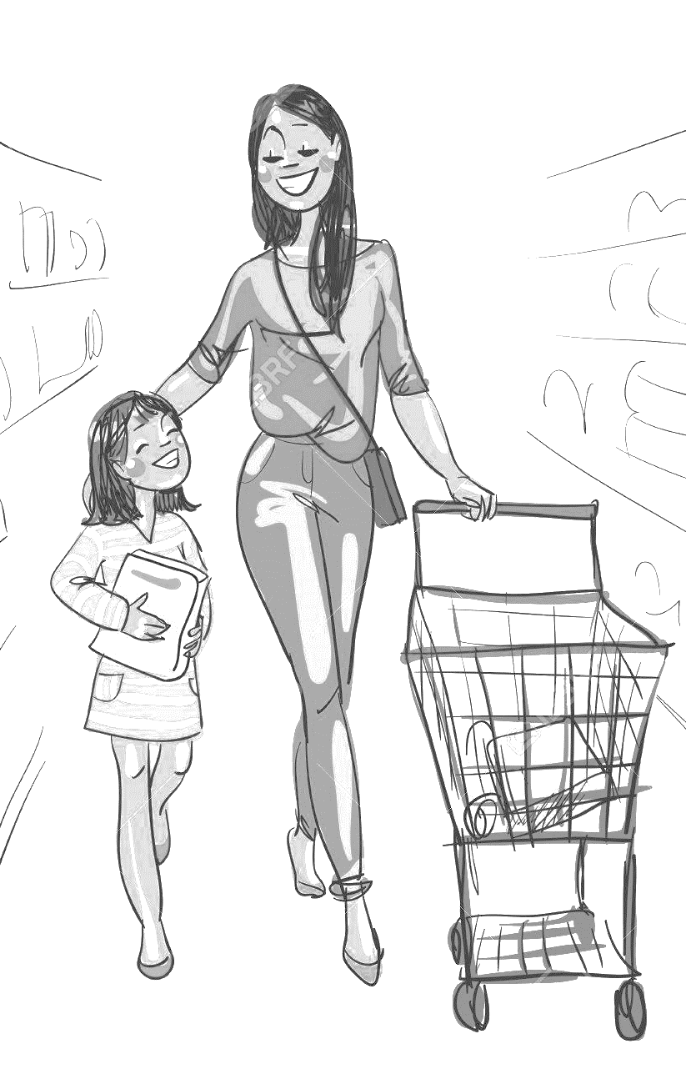

Fruits and Vegetables

TRANSCRIPT

One
Teacher – Can you see the pears?
Mary – Yes, I can.
Teacher – Colour two of them green.
Mary – Pardon?
Teacher – Colour two pears green.
Mary – OK.

Two
Teacher – Look at the oranges.
Mary – Can I colour them?
Teacher – Yes. Colour the oranges orange!
Mary – Of course.

Three
Teacher – Now colour the beans.
Mary – What colour?
Teacher – Brown.
Mary – Ok. Brown beans.

Four
Teacher – Can you see the potatoes?
Mary – Yes.
Teacher – Colour the potatoes red.
Mary – I love red potatoes!

Five
Mary – Can I colour the tomatoes?
Teacher – Yes. Just one. Colour one tomato in yellow.
Mary – One yellow tomato!

ANSWER KEY

- Two pears - green
- Oranges - orange
- Beans – orange
- Potatoes – red
- One tomato - yellow

