Name: ____________________________ Surname: ____________________________ N^{ber}: ____ Grade/Class: _____
Assessment: _____________________________ | Date: ___________________________________________________
 | Teacher’s signature:  ___________________________ | Parent’s signature:  ___________________________

Listen and match.

Soup Pot

----------------------------------------------------------------------------------------------------------------

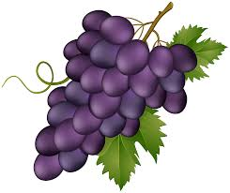

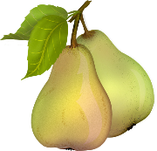

Fruit Salad

TRANSCRIPT

One
Mother – Emily! Can you help me to make a soup?
Emily – Sure!
Mother – Give me potatoes, carrots and peas, please.
Emily – Ok. Potatoes, carrots and peas. Here you are. Do you want a lettuce?
Mother – No, thanks. It’s not necessary.

Two
Emily – Can I make a fruit salad?
Mother – Sure! You’ve got pears on the table.
Emily – No, no pears. It’s a fruit salad with apples, strawberries and oranges.
Mother – Ok! Good choice.

ANSWER KEY

SOUP POT: potatoes, carrots and peas

FRUIT SALAD: pe apples, strawberries and oranges

