Name: ____________________________ Surname: ____________________________ N^{ber}: ____ Grade/Class: _____
Assessment: _____________________________ | Date: ___________________________________________________
 | Teacher’s signature:  ___________________________ | Parent’s signature:  ___________________________

1) Fruit – Listen and number.
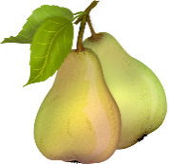
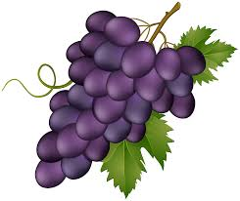
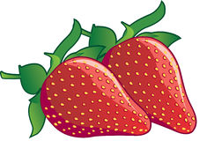

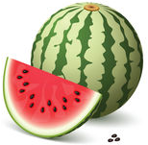
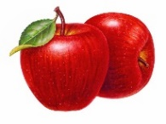
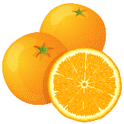
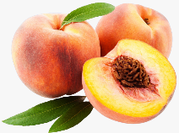
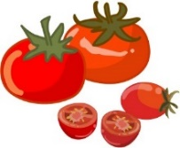

1) Vegetables – Listen and number.
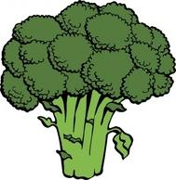
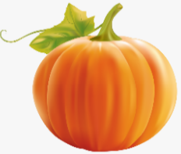
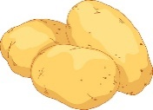

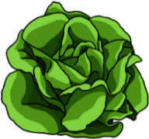
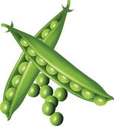
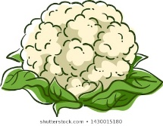
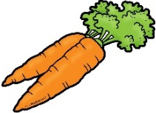

TRANSCRIPT

Exercise 1
- Bananas
- Tomatoes
- Oranges
- Grapes
- Pears
- Watermelon
- Strawberries
- Pineapple
- Peaches
- Apples

Exercise 2
- Pumpkin
- Carrots
- Potatoes
- Broccoli
- Peas
- Onions
- Beans
- Cabbage
- Lettuce
- Cauliflower

ANSWER KEY

EXERCISE 1
- Bananas
- Tomatoes
- Oranges
- Grapes
- Pears
- Watermelon
- Strawberries
- Pineapple
- Peaches
- Apples

EXERCISE 2
- Pumpkin
- Carrots
- Potatoes
- Broccoli
- Peas
- Onions
- Beans
- Cabbage
- Lettuce
- Cauliflower

