Name: ____________________________ Surname: ____________________________ N^{ber}: ____ Grade/Class: _____
Assessment: _____________________________ | Date: ___________________________________________________
 | Teacher’s signature:  ___________________________ | Parent’s signature:  ___________________________

Listen to Jack and Kim. Tick ( ) what they like and cross ( ) what they don’t like.

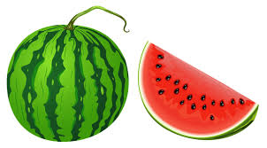
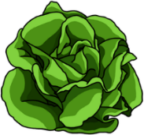

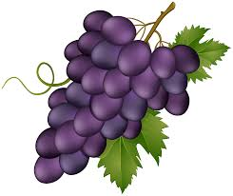

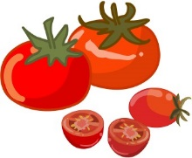
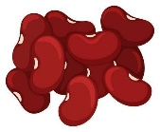

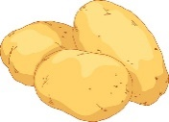
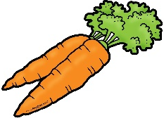
Jack
Kim

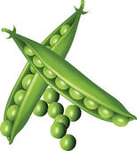
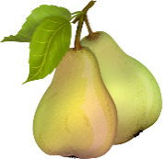

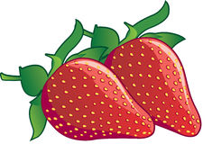
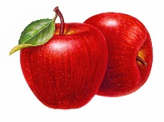

TRANSCRIPT

Situation 1:
Hello my name’s Jack. I love fruit but I don’t like grapes. My favourite fruits are pears and strawberries.
I like vegetables, for example, carrots and lettuce. I don’t like beans.

Situation 2:
Hi I’m Kim and I don’t like peas! I like potatoes and lettuce.
My favourite fruits are watermelon and apples. I don’t like tomatoes.

ANSWER KEY

JACK
- Tick: pears; strawberries; carrots; lettuce
- Cross: grapes; beans

Kim
- Tick: potatoes; lettuce; watermelon; apples
- Cross: peas; tomatoes

