Name: ____________________________ Surname: ____________________________ N^{ber}: ____ Grade/Class: _____
Assessment: _____________________________ | Date: ___________________________________________________
 | Teacher’s signature:  ___________________________ | Parent’s signature:  ___________________________

Listen and tick.

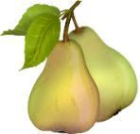
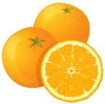
- What is Ana’s favourite fruit?
a) b) c)

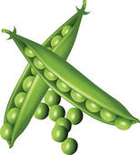
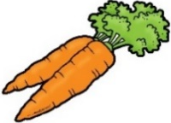
2) What vegetable do you like?
a) b) c)

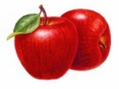
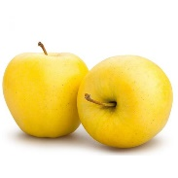
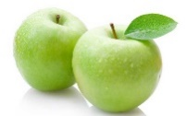
3) The apples are…
a) b) c)

4) How many vegetables are in the soup?
2
3
4
a) b) c)

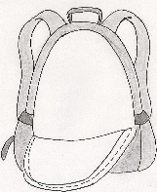
5) Where is the banana?
a) b) c)

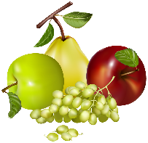
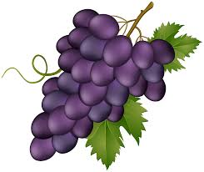
6) To make a fruit salad…
a) b) c)

TRANSCRIPT

EXERCISE 1

One:
BOY: What’s your favourite fruit Ana?
GIRL: Well, I like oranges and pears, but my favourite fruit is pineapple.
BOY: Me too. I love pineapple
Two:
BOY: Oh No! Peas soup. I don’t like peas.
GIRL: You don’t like peas! What vegetable do you like?
BOY: I like carrots, for example.
Three:
MAN: Those apples are delicious.
GIRL: Which ones? The red or the green apples.
MAN: No, the yellow ones, over there. Can you see them?
GIRL: Oh I see, the yellow apples.
Four:
WOMAN: Let’s make a soup.
GIRL: Ok what vegetables do you want?
WOMAN: Carrots, potatoes and lettuce.
GIRL: Anything else.
WOMAN: No, thank you. Just carrots, potatoes and lettuce.
Five:
BOY: Where is my banana? It is not in my schoolbag!
GIRL: It’s on the table under your book.
BOY: Under my book? Oh, I see. Thank you.
Six:
BOY: Today, it’s my turn to make a fruit salad!
GIRL: What fruit do you want?
BOY: Apples, grapes and strawberries.
GIRL: Here you are: apples, grapes and strawberries.

ANSWER KEY

- c
- b
- a
- b
- a
- a

