Name: ____________________________ Surname: ____________________________ N^{ber}: ____ Grade/Class: _____
Assessment: _____________________________ | Date: ___________________________________________________
 | Teacher’s signature:  ___________________________ | Parent’s signature:  ___________________________

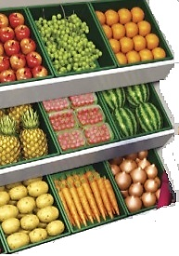
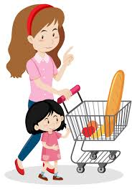
Look at the picture. Write Yes or No.
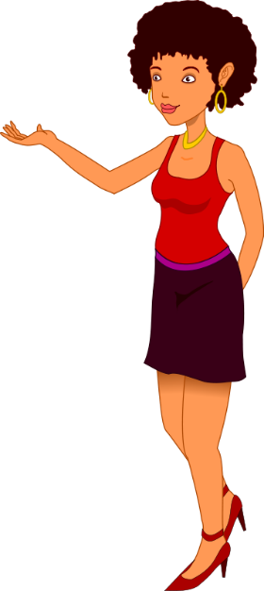

Kathy
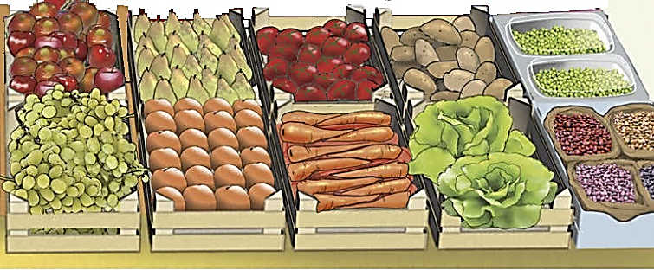
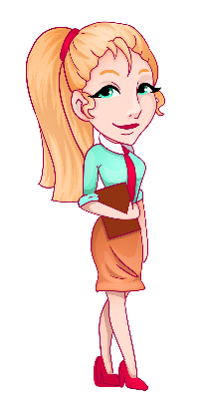

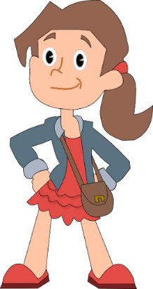
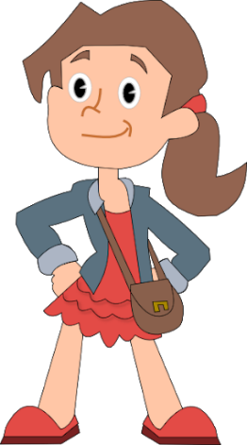
Do you like grapes?
No, I don’t.
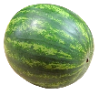
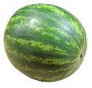
John
Fiona
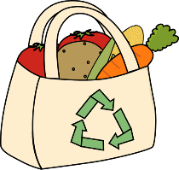
Tom
Kim

- There are fruit and vegetables. _______
- There are two pineapples in Fiona’s trolley. _______
- John has three bananas. _______
- There is a bag near John. _______
- Kim likes grapes. _______
- Kathy is near her father. _______
- There are seven people. _______
ANSWER KEY

- Yes
- No
- Yes
- Yes
- No
- No
- Yes

