Name: ____________________________ Surname: ____________________________ N^{ber}: ____ Grade/Class: _____
Assessment: _____________________________ | Date: ___________________________________________________
 | Teacher’s signature:  ___________________________ | Parent’s signature:  ___________________________

1) Read.
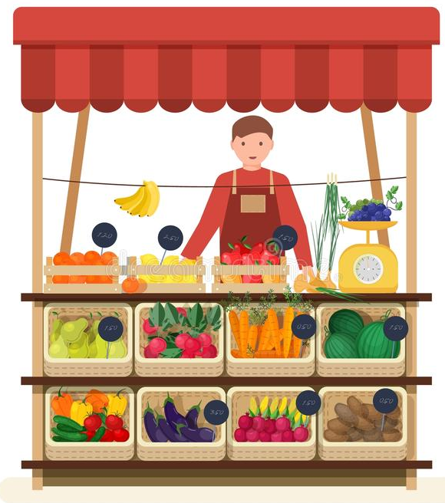
Thank you Tom and Liza! Now I can make delicious soup for dinner!

Mum, can I make a fruit salad this afternoon?
Good idea Tom! It’s a healthy snack.
Are there apples and grapes?
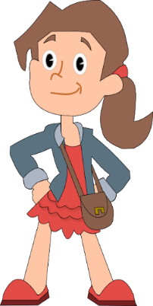
There are grapes but there aren’t apples.

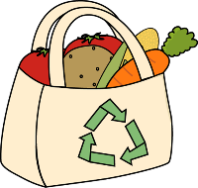

2) Write Yes or No.

- There is a woman, a man and three children. _______
- The boy’s name is Tom. _______
- There are vegetables in the bag. _______
- The soup is for the afternoon snack. _______
- Liza makes the fruit salad. _______
- There are grapes for the fruit salad. _______
- There are apples for the fruit salad. _______
ANSWER KEY

- No
- Yes
- Yes
- No
- No
- Yes
- No

