Name: ____________________________ Surname: ____________________________ N^{ber}: ____ Grade/Class: _____
Assessment: _____________________________ | Date: ___________________________________________________
 | Teacher’s signature:  ___________________________ | Parent’s signature:  ___________________________
Read and tick ( ) what they like and cross ( ) what they don’t like.
David: Hi, Emma! Do you like fruit?
Emma: Yes, I do. I like grapes and apples.
David: What fruit don’t you like?
Emma: Let me think… Ah! I don’t like watermelon.
David: You don’t like watermelon? It’s my favourite fruit!
Emma: Really?
David: I love watermelon and bananas but I don’t like oranges.
Emma: And what is your favourite vegetable?
David: I love peas but I don’t like beans. And you?
Emma: I like lettuce but I don’t like broccoli.

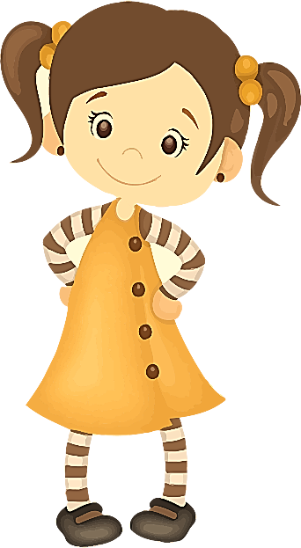

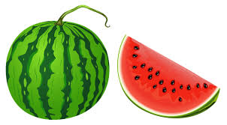

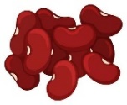
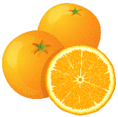
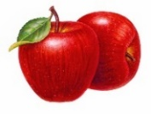
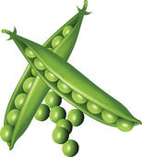
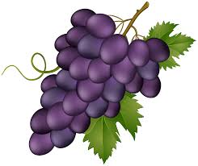
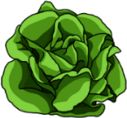
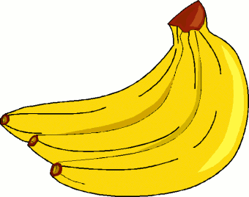

David
Emma

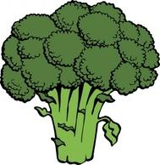

ANSWER KEY

DAVID
- Tick: watermelon; bananas; peas
- Cross: oranges; beans

EMMA
- Tick: grapes; apples; lettuce
- Cross: watermelon; broccoli

