Name: ____________________________ Surname: ____________________________ N^{ber}: ____ Grade/Class: _____
Assessment: _____________________________ | Date: ___________________________________________________
 | Teacher’s signature:  ___________________________ | Parent’s signature:  ___________________________

1) Read. Tick what Harry likes and cross what he doesn’t like
Hi, my name’s Harry and I’m nine years old. I like oranges and apples but I don’t like pears. I like carrots and potatoes but I don’t like lettuce. And you, what do you like?

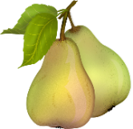 | 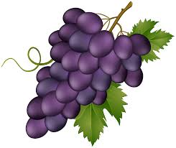 | 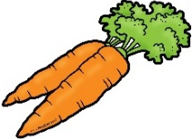
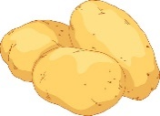 | 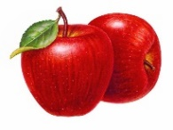 | 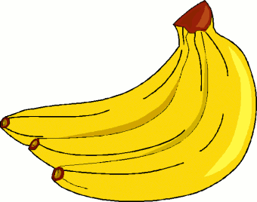
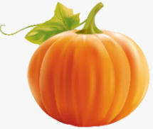 | 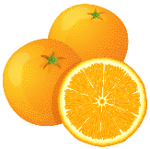 | 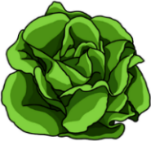

2) Read and complete the text. Draw your face.
Hello, my name’s ____________________ and I’m ___________________ years
old. My favourite fruit is _______________________ and my favourite vegetable is ________________________.

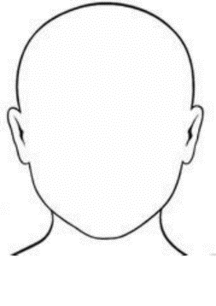

This is me

ANSWER KEY

EXERCISE 1
- Tick: oranges; apples; carrots; potatoes
- Cross: pears; lettuce

EXERCISE 2
Suggestion:
Hello, my name’s Paulo and I’m nine years old. My favourite fruit is pineapple and my favourite vegetable is broccoli.

