Name: ____________________________ Surname: ____________________________ N^{ber}: ____ Grade/Class: _____
Assessment: _____________________________ | Date: ___________________________________________________
 | Teacher’s signature:  ___________________________ | Parent’s signature:  ___________________________

Find the 6 differences.
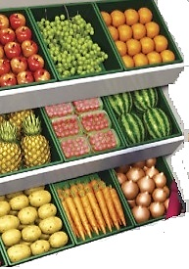
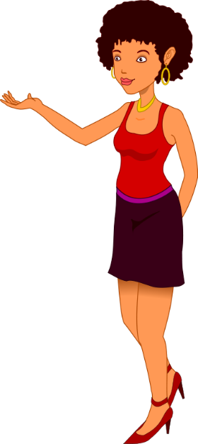

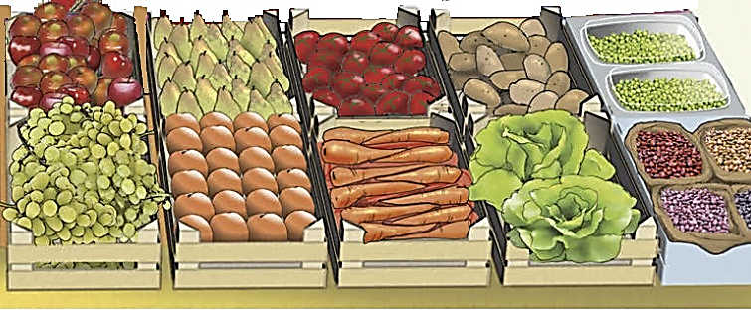
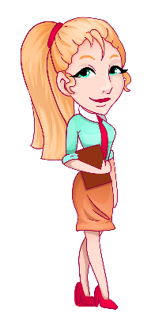

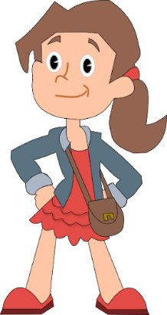
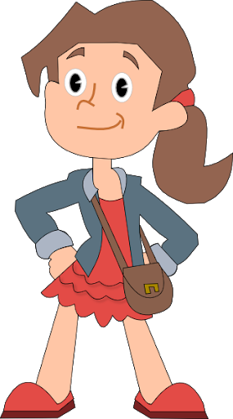
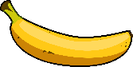
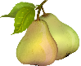
Do you like grapes?
Yes, I do.
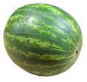
John
Fiona
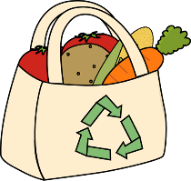
Tom
Kim

Name: ____________________________ Surname: ____________________________ N^{ber}: ____ Grade/Class: _____
Assessment: _____________________________ | Date: ___________________________________________________
 | Teacher’s signature:  ___________________________ | Parent’s signature:  ___________________________

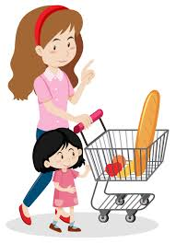
Find the 6 differences.

Kathy

Do you like grapes?
No, I don’t.
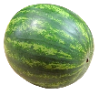
John
Fiona
Tom
Kim

KEY ANSWER

 | PICTURE 1 | PICTURE 2
1 | There is no woman pushing a shopping trolley with her daughter (in the top right hand corner) | There is a woman pushing a shopping trolley and her daughter (in the top right hand corner).
2 | There is one watermelon in Fiona’s shopping trolley. | There is two watermelons in Fiona’s shopping trolley.
3 | There are no apples on the floor near Fiona. | There are two apples on the floor, near Fiona.
4 | John has 2 pears. | John has three bananas.
5 | There is no shopping bag next to John. | There is a shopping bag next to John
6 | Kim likes grapes. | Kim doesn’t like grapes.

