Name: ____________________________ Surname: ____________________________ N^{ber}: ____ Grade/Class: _____
Assessment: _____________________________ | Date: ___________________________________________________
 | Teacher’s signature:  ___________________________ | Parent’s signature:  ___________________________

STUDENT A

- Answer your partners’ questions.

- Ask your partner: “Do you like …?”
Put a tick ( ) or a cross ( ).

 | 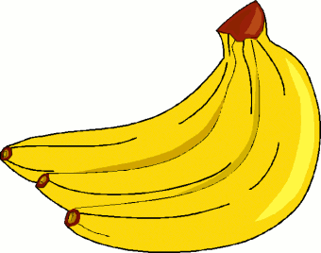 | 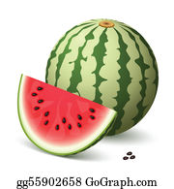 | 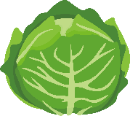 | 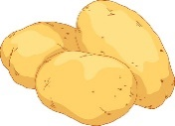 | 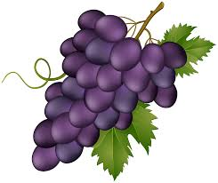 | 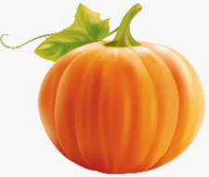
My partner’s answers

Name: ____________________________ Surname: ____________________________ N^{ber}: ____ Grade/Class: _____
Assessment: _____________________________ | Date: ___________________________________________________
 | Teacher’s signature:  ___________________________ | Parent’s signature:  ___________________________

STUDENT B

- Ask your partner: “Do you like …?”
Put a tick ( ) or a cross ( ).

 | 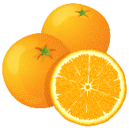 | 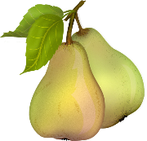 | 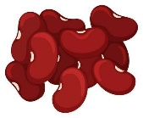 | 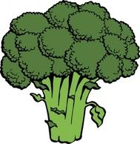 | 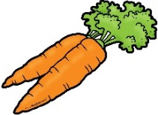 | 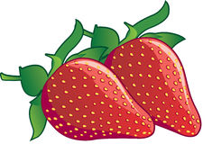
My partner’s answers

- Answer your partners’ questions.

ANSWER KEY:
Student B:
Do you like oranges?
Do you like pears?
Do you like beans?
Do you like broccoli?
Do you like carrots?
Do you like strawberries?
Student A:
Yes, I do. / No, I don’t.

Student A:
Do you like bananas?
Do you like watermelon?
Do you like cabbage?
Do you like potatoes?
Do you like grapes?
Do you like pumpkin?
Student B:
Yes, I do. / No, I don’t.

