Name: ____________________________ Surname: ____________________________ N^{ber}: ____ Grade/Class: _____
Assessment: _____________________________ | Date: ___________________________________________________
 | Teacher’s signature:  ___________________________ | Parent’s signature:  ___________________________

Look at the picture answer the questions.

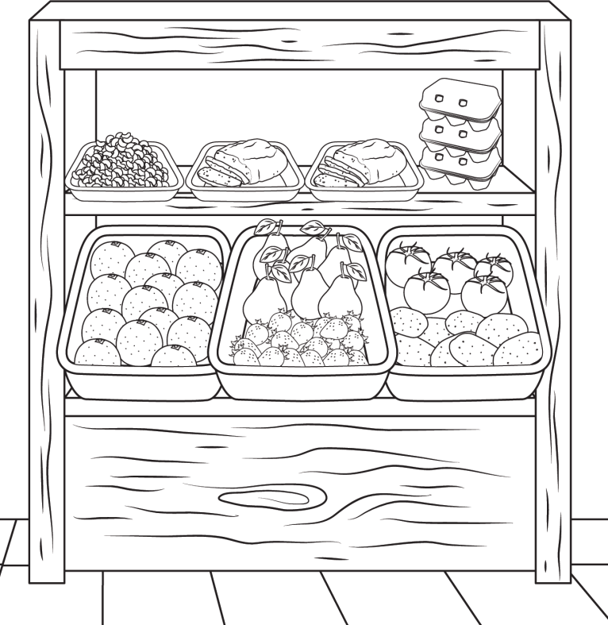
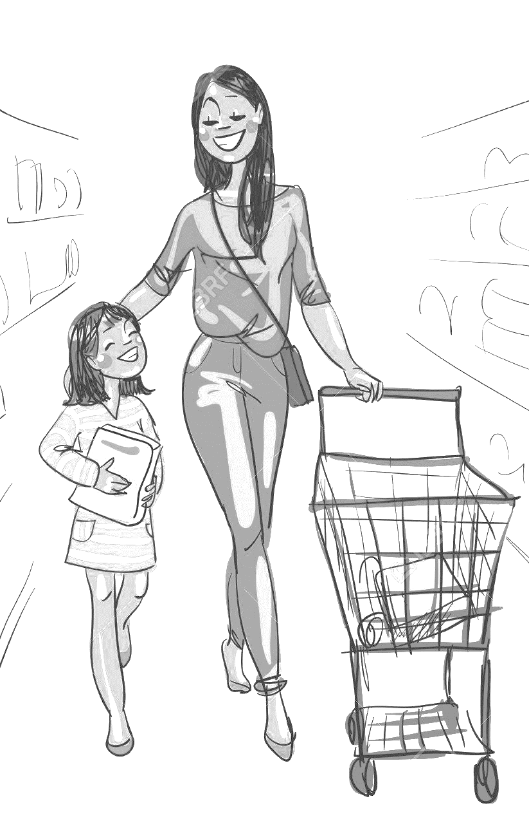

Fruits and Vegetables

TEACHER’S QUESTIONS:

- How many people can you see?
- What fruits are there?
- How many pears are there?
- Are there beans?
- How many tomatoes are there?
- What’s your favourite fruit?
- What vegetables do you like?
- What fruit don’t you like?

ANSWER KEY:
- There are two people.
- There are oranges, pears, and tomatoes.
- There are six pears.
- Yes, there are.
- There are 5 tomatoes.
- My favourite fruit is…
- I like…
- I don’t like…

