Name: ____________________________ Surname: ____________________________ N^{ber}: ____ Grade/Class: _____
Assessment: _____________________________ | Date: ___________________________________________________
 | Teacher’s signature:  ___________________________ | Parent’s signature:  ___________________________

STUDENT A
1) Look at your soup pot. Answer your partner’s questions.

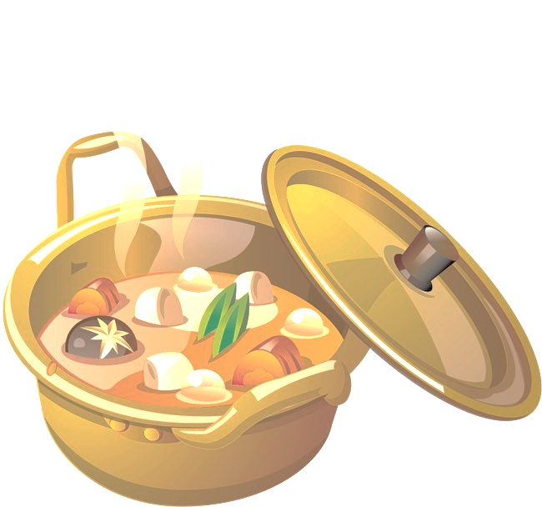

Soup Pot

2) Your partner is making a fruit salad. Ask your partner: “Is there…?” / “Are there…?”
Put a tick ( ) or a cross ( ).

 | 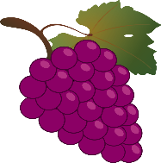 | 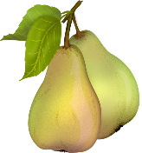 | 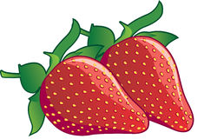 | 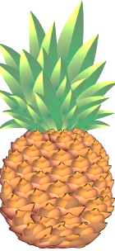 |  | 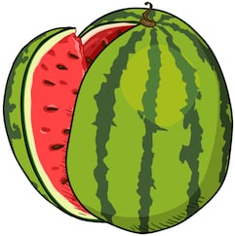
My partner’s answers

STUDENT B
Name: ____________________________ Surname: ____________________________ N^{ber}: ____ Grade/Class: _____
Assessment: _____________________________ | Date: ___________________________________________________
 | Teacher’s signature:  ___________________________ | Parent’s signature:  ___________________________

1) Your partner is making a soup. Ask your partner: “Is there…?” / “Are there…?”
Put a tick ( ) or a cross ( ).
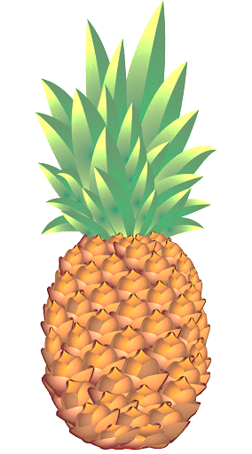
 | 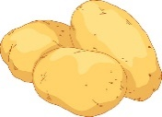 | 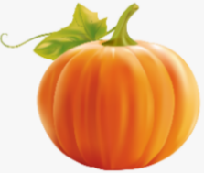 |  | 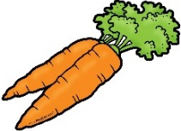 | 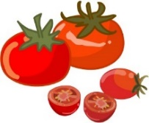 | 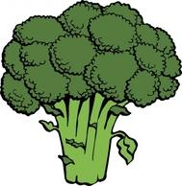
My partner’s answers

2) Look at your fruit salad bowl. Answer your partner’s questions.

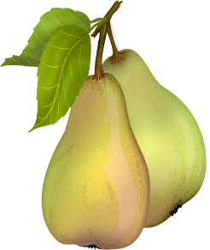
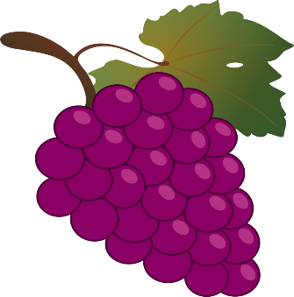

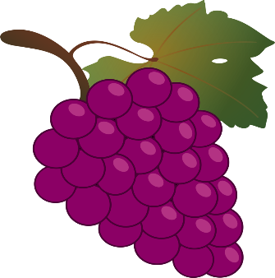
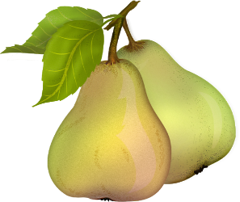
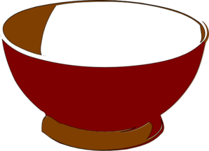

Fruit Salad

ANSWER KEY:

Student B: Are there potatoes? / Student A: Yes, there are.
Student B: Is there pumpkin? / Student A: No, there isn’t.
Student B: Is there cabbage? / Student A: Yes, there is.
Student B: Are there carrots? / Student A: Yes, there are.
Student B: Are there tomatoes? / Student A: No, there aren’t.
Student B: Is there broccoli? / Student A: Yes, there is.

Student A: Are there grapes? / Student B: Yes, there are.
Student A: Are there pears? / Student B: Yes, there are.
Student A: Are there strawberries? / Student B: No, there aren’t.
Student A: Is there pineapple? / Student B: Yes, there is.
Student A: Are there bananas? / Student B: Yes, there are.
Student A: Is there watermelon? / Student B: No, there isn’t.

