Name: ____________________________ Surname: ____________________________ N^{ber}: ____ Grade/Class: _____
Assessment: _____________________________ | Date: ___________________________________________________
 | Teacher’s signature:  ___________________________ | Parent’s signature:  ___________________________

1) Look, fill in the gaps and circle.

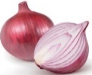
a)
Do you like o __ __ __ n ?
Yes, I do. / No, I don’t.
Yes, I do. / No, I don’t.

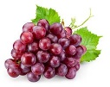
b)
Do you like g __ __ p __ __ ?

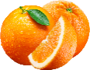
c)
Do you like o__ __ n __ e __ ?
Yes, I do. / No, I don’t.

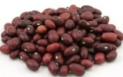
d)
Yes, I do. / No, I don’t.
Do you like t __ m __ __ __ e __?
Yes, I do. / No, I don’t.
Do you like b__ __ __ s ?

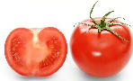
e)

2) And you?

a)
Do you like watermelon?
______ , _____ ______.

______ , _____ ______.

b)
Do you like cauliflower?

ANSWER KEY

EXERCISE 1
- Onion / No, I don’t.
- Grapes / Yes, I do.
- Oranges / No, I don’t.
- Beans / Yes, I do.
- Tomatoes / No, I don’t.

EXERCISE 2
- Yes, I do. / No, I don’t.
- Yes, I do. / No, I don’t.

