Name: ____________________________ Surname: ____________________________ N^{ber}: ____ Grade/Class: _____
Assessment: _____________________________ | Date: ___________________________________________________
 | Teacher’s signature:  ___________________________ | Parent’s signature:  ___________________________
1) Look, circle the correct option and write.
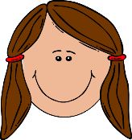
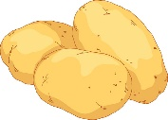
a)
I like / don’t like p__ __ __ t __ __ s.

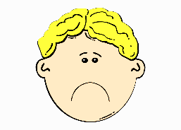
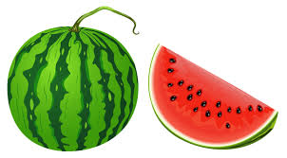
b)
I like / don’t like w__ t __ __ m __ l __ n.

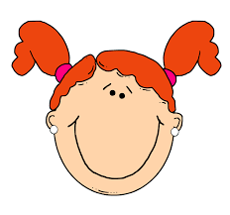
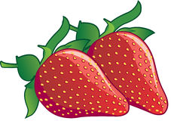
c)
I like / don’t like s__ r __w __ __ r __ __e s.

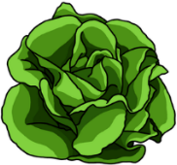
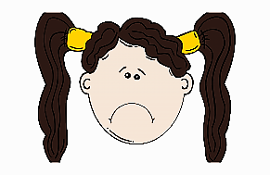
d)
I like / don’t like l__ __ t __ c __.

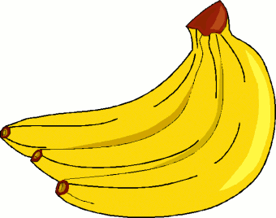
e)
I like / don’t like b__ n__ __ a.

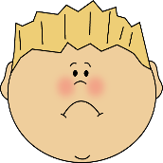
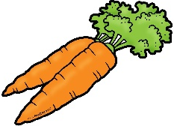
f)
I like / don’t like c__ r__ __ t s

2) And you?
a)
______________________________
What fruit do you like?

b)
______________________________
What vegetable don’t you like?

ANSWER KEY

EXERCISE 1
- I like potatoes.
- I don’t like watermelon.
- I like strawberries.
- I don’t like lettuce.
- I like bananas.
- I don’t like carrots.

EXERCISE 2
Suggestion
- I like strawberries.
- I don’t like carrots

