Name: ____________________________ Surname: ____________________________ N^{ber}: ____ Grade/Class: _____
Assessment: _____________________________ | Date: ___________________________________________________
 | Teacher’s signature:  ___________________________ | Parent’s signature:  ___________________________

1) Look and unscramble.
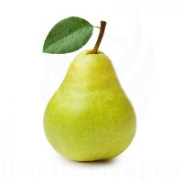
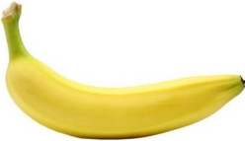
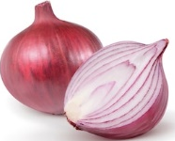
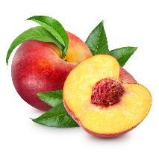

c e p a h
__ __ __ __ __
n a a n a b
__ __ __ __ __ __
n o i n o
__ __ __ __ __
r p a e
__ __ __ __

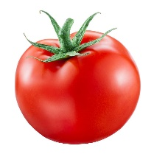
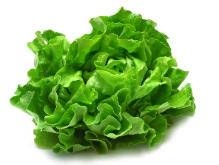
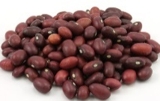
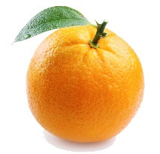

__ __ __ __ __ __ __
e l c t t e u
a b n e s
__ __ __ __ __
m t t o o a
__ __ __ __ __ __
g e o a r n
__ __ __ __ __ __

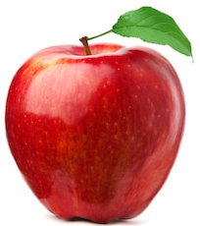
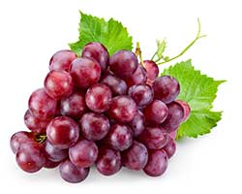
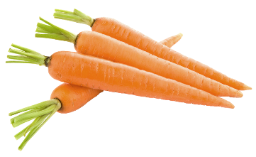
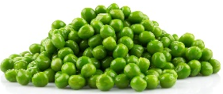

__ __ __ __ __ __ __
p l a p e
__ __ __ __ __
c o r r s t a
r p g a e s
__ __ __ __ __
s p a e
__ __ __ __

2) Answer.
a) What’s your favourite fruit? ___________________
b) What’s your favourite vegetable? ___________________
ANSWER KEY

EXERCISE 1
pears / peach / banana / onion
orange / lettuce / beans / tomato
peas / apple / carrots / grapes

EXERCISE 2
My favourite fruit is pineapple.
My favourite vegetable is cabbage.

