|  |  |  |
| --- | --- | --- |
| **Name:** ____________________________ **Surname:** ____________________________ **Nber: ____ Grade/Class:** _____ | | |
| **Assessment:** _____________________________ | **Date:** ___________________________________________________ | |
| **Teacher’s signature:**  **___________________________** | **Parent’s signature:**  **___________________________** |

**Write and match.**

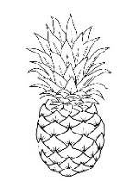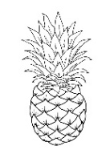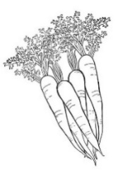

1. G r __ p __ __
2. C __ r r __ t __
3. L __ t t __ c e
4. P __ n e __ p p __ __ s
5. __ p p __ e __
6. P __ __ s
7. O r __ __ g __ s
8. T __ m __ __ __ e s
9. P e __ r __
10. P __ t __ t __ e __
11. B e __ __ s
12. W __ t __ __ m __ l __ n

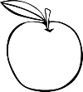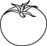

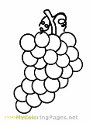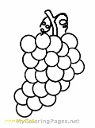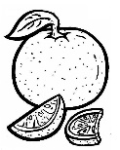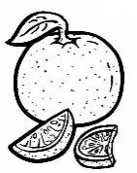

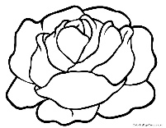

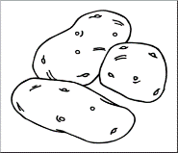

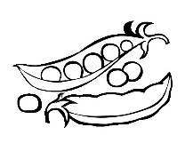

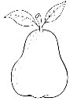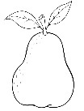

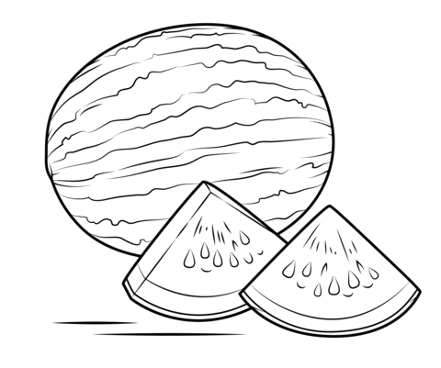



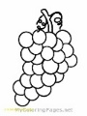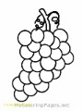**ANSWER KEY**

1. Grapes

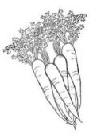

1. Carrots

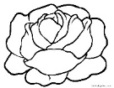

1. Lettuce

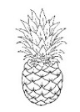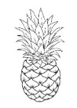

1. Pineapples

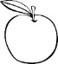

1. Apples

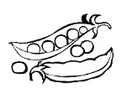

1. Peas

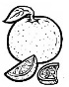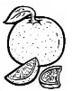

1. Oranges





1. Tomatoes

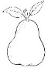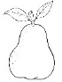

1. Pears



1. Potatoes



1. Beans



1. watermelon