Name: ____________________________ Surname: ____________________________ N^{ber}: ____ Grade/Class: _____
Assessment: _____________________________ | Date: ___________________________________________________
 | Teacher’s signature:  ___________________________ | Parent’s signature:  ___________________________

1) Label the pictures.
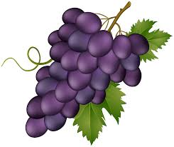
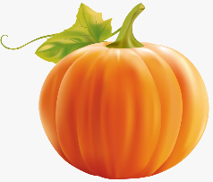
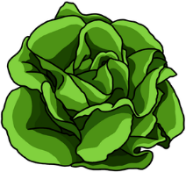
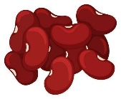

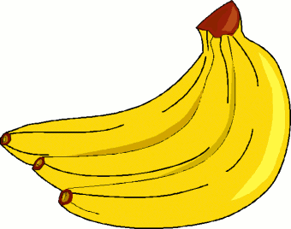
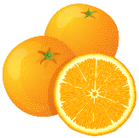
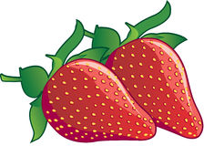
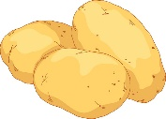

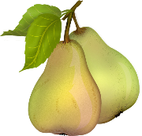
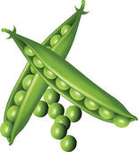
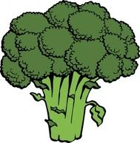
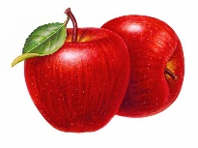
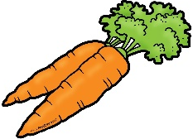

1. Strawberries 2. Bananas 3. Lettuce 4. Pumpkin 5. Pineapple 6. Carrots 7. Peas
8. Oranges 9. Potatoes 10. Broccoli 11. Pears 12. Grapes 13. Beans 14. Apples

2) Write the words in the correct column.

FRUIT | VEGETABLES
________________________  ________________________  ________________________  ________________________  ________________________  ________________________  ________________________ | ________________________  ________________________  ________________________  ________________________  ________________________  ________________________  ________________________

ANSWER KEY

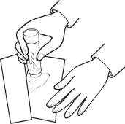
EXERCISE 1:
G E
U L
3. lettuce / 13. beans / 4. pumpkin / 12. grapes / 5. pineapple
1. strawberries / 8. oranges / 9. potatoes / 2. bananas
6. carrots / 7. peas / 11. pears / 10. broccoli / 14. apples

EXERCISE 2:
FRUIT | VEGETABLES
Grapes  Pineapple  Strawberries  Oranges  Bananas  Pears  Apples | Lettuce  Beans  Pumpkin  Potatoes  Carrots  Peas  Broccoli

