Name: ____________________________ Surname: ____________________________ N^{ber}: ____ Grade/Class: _____
Assessment: _____________________________ | Date: ___________________________________________________
 | Teacher’s signature:  ___________________________ | Parent’s signature:  ___________________________

- Look at the picture and write.

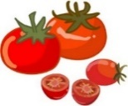  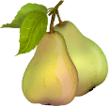 | 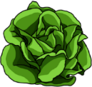

I ________________ and ________________ but I ______________ _________________.

- And you? Write about the fruits or vegetables you like and don’t like.

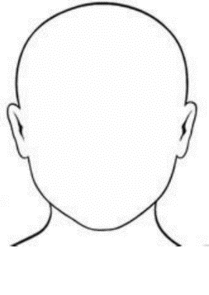

This is me

I ________________ and ________________ but I ______________ _________________.

ANSWER KEY

- I like pears and tomatoes but I don’t like lettuce.
- I like oranges and peaches but I don’t like carrots.

