Name: ____________________________ Surname: ____________________________ N^{ber}: ____ Grade/Class: _____
Assessment: _____________________________ | Date: ___________________________________________________
 | Teacher’s signature:  ___________________________ | Parent’s signature:  ___________________________

1) Write about what Emma likes or doesn’t like. Follow the example.

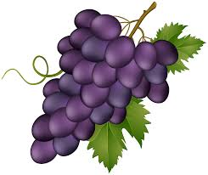
Hi! I’m Jason. I like _______________ and ______________ but I don’t like ______________ or ______________.
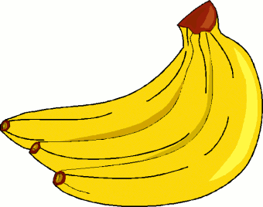
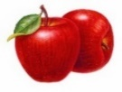

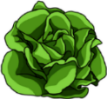
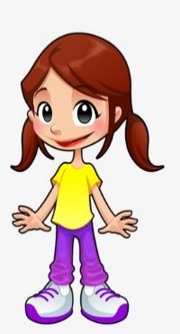
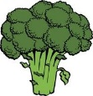
_______________________________
_______________________________
_______________________________
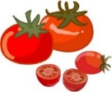
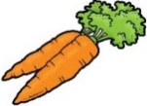

Sue

2) What about you?
a) What’s your favourite fruit? It’s ______________________________.
b) What fruit(s) don’t you like? I ________________________________.
a) What’s your favourite vegetable? It’s ______________________________.
b) What vegetable(s) don’t you like? I ________________________________.

ANSWER KEY

1)
Hi! I’m Jason. I like bananas and apples but I don’t like grapes or pineapples.
Hi! I’m Sue. I like bananas and apples but I don’t like grapes or pineapples.

2)
a) It’s... (e.g. pineapple)
b) I don’t like… (e.g. oranges or pears)
c) It’s… (e.g. cauliflower)
d) I don’t like… (e.g. beans or peas)

