Name: ____________________________ Surname: ____________________________ N^{ber}: ____ Grade/Class: _____
Assessment: _____________________________ | Date: ___________________________________________________
 | Teacher’s signature:  ___________________________ | Parent’s signature:  ___________________________

Reorder the questions and answer.
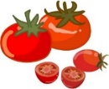
you / like / do /

a)
___________________________?
_____ , ___ _______
like / do / you /
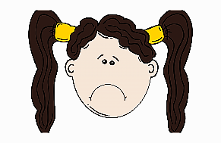
b)
_____ , ___ _______

___________________________?

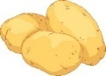
like / you / do /
c)
_____ , ___ _______

___________________________?

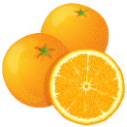
do / like / you /
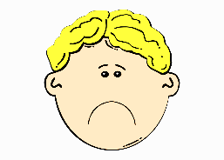
d)
_____ , ___ _______

___________________________?

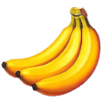
like / you / do /
e)
___________________________?
_____ , ___ _______

ANSWER KEY

- Do you like tomatoes? Yes, I do.
- Do you like beans? No, I don’t.
- Do you like potatoes? Yes, I do.
- Do you like oranges? No, I don’t.
- Do you like bananas? Yes, I do.

