Name: ____________________________ Surname: ____________________________ N^{ber}: ____ Grade/Class: _____
Assessment: _____________________________ | Date: ___________________________________________________
 | Teacher’s signature:  ___________________________ | Parent’s signature:  ___________________________

1) Look and write what they like or don’t like.

I ______________
___________ or ___________

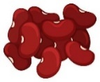
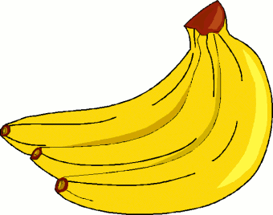
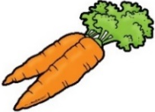
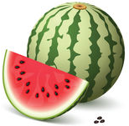
a) b)

I ______________
___________ and ___________

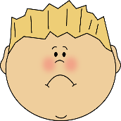

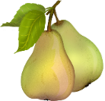
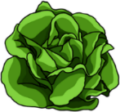
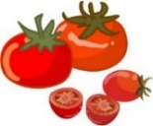
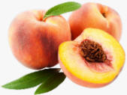
c) d)

I ______________
___________ and ___________

I ______________
___________ or ___________

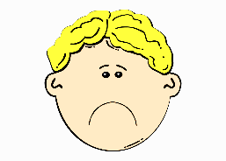

2) And you?
a) What fruits do you like? I __________ _____________ and ______________.
b) What fruits don’t you like? I __________ ______________ or ______________.
a) What vegetables do you like? I __________ _____________ and ______________.
b) What vegetables don’t you like? I __________ ______________ or ______________.

ANSWER KEY

1)
a) I like watermelon and bananas.
b) I don’t like carrots or beans.
c) I don’t like peaches or pears.
d) I like tomatoes and lettuce.

2)
a) I like… apples and bananas.
b) I don’t like… strawberries or cherries.
c) I like… carrots and lettuce.
d) I don’t like… peas or beans.

