Name: ____________________________ Surname: ____________________________ N^{ber}: ____ Grade/Class: _____
Assessment: _____________________________ | Date: ___________________________________________________
 | Teacher’s signature:  ___________________________ | Parent’s signature:  ___________________________

- Listen and write the names.

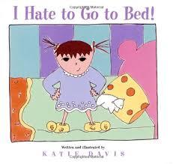

Frank Romano Harold Bill
Camilla Eduardo Ken Max

- Listen and write the names.

Harold
Max

Frank
Romano

Eduardo
Camilla

Ken
Bill
Script:
Ken loves running, Romano doesn’t like running.
Eduardo loves dancing, Harold doesn’t like dancing.
Max loves sleeping, Camilla hates sleeping.
Frank loves writing, Bill doesn’t like writing.

