Name: ____________________________ Surname: ____________________________ N^{ber}: ____ Grade/Class: _____
Assessment: _____________________________ | Date: ___________________________________________________
 | Teacher’s signature:  ___________________________ | Parent’s signature:  ___________________________

- Listen and put the pictures in the correct order.
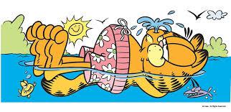

Answer key
8
2

3
5

1
6
7
4

Script
Every weekend Garfield has got a plan. In the mornings, he likes singing in the shower. In the afternoons Garfield and Oddie go to the forest. Garfield likes swimming in the lake. After that, he likes fishing there. Garfield and Oddie like camping and they eat the fish there. Then he likes running home. At home, he likes cooking. At night, he likes watching TV. And at the end, his favorite hobbie comes: Sleeping!

