Name: ____________________________ Surname: ____________________________ N^{ber}: ____ Grade/Class: _____
Assessment: _____________________________ | Date: ___________________________________________________
 | Teacher’s signature:  ___________________________ | Parent’s signature:  ___________________________
- Listen and match.

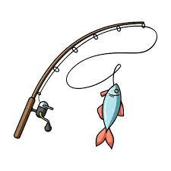
Garfield

Oddie

Fidel

Pinky

Sylvester

Answer key
Garfield

Oddie

Fidel

Pinky

Sylvester

Script:
Fidel loves relaxing. Oddie loves fishing.
Pinky loves painting. Sylvester loves singing.Garfield loves swinging.

