Name: ____________________________ Surname: ____________________________ N^{ber}: ____ Grade/Class: _____
Assessment: _____________________________  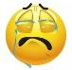  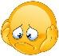 | Date: ___________________________________________________
 | Teacher’s signature:  ___________________________ | Parent’s signature:  ___________________________

- Listen and fill in the blanks.

My favorite hobby is ________________________ with my family. My father likes __________ there, and my mother likes __________. My younger brother loves ____________________ with his friends on the beach. My older brother likes ___________________ with his phone near me. My younger sister likes __________ but my older sister doesn’t like __________. She just likes __________ on the beach. And our dog Lucky loves __________ near my chair.I love __________ with my family, and I love our family holidays.
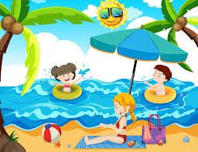

Answer key & Script
My favorite hobby is going to the beach with my family. My father likes fishing there, and my mother likes reading. My younger brother loves playing volleyball with his friends on the beach. My older brother likes playing chess with his phone near me. My younger sister likes swimming but my older sister doesn’t like swimming. She just likes walking on the beach. And our dog Lucky loves sleeping near my chair.I love talking with my family, and I love our family holidays.

