Name: ____________________________ Surname: ____________________________ N^{ber}: ____ Grade/Class: _____
Assessment: _____________________________ | Date: ___________________________________________________
 | Teacher’s signature:  ___________________________ | Parent’s signature:  ___________________________

- Listen and write the names.
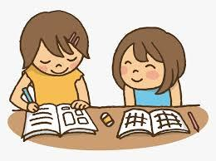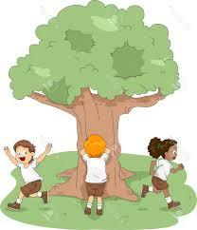

Janet

Trish, Ali and Mehmet

Blair and John

Lucy, Stefan and Benedict

Hamid

Sharon and Caroline

Pablo and Raul

Cynthia and Cecil

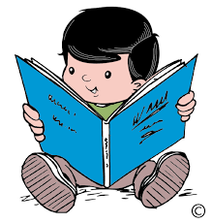

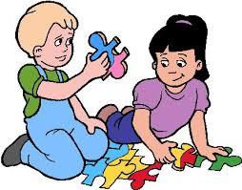

Answer key
Sharon and Caroline
Lucy, Stefan and Benedict

Pablo and Raul
Cynthia and Cecil
Hamid
Trish, Ali and Mehmet

Janet
Blair and John

Script

Janet likes listening to music.
Blair and John like doing puzzles.
Trish, Ali and Mehmet like singing.
Pablo and Raul like watching TV.
Hamid likes reading.
Cynthia and Cecil like playing tennis.
Lucy, Stefan and Benedict like playing hide and seek.
Sharon and Caroline like studying.

