Name: ____________________________ Surname: ____________________________ N^{ber}: ____ Grade/Class: _____
Assessment: _____________________________ | Date: ___________________________________________________
 | Teacher’s signature:  ___________________________ | Parent’s signature:  ___________________________

- Read and write names.
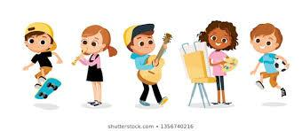

Hi! We are five friends. We have very good hobbies.
Leyla likes painting, Barry loves playing football, David likes skating, Henrietta loves playing the flute, and I love playing the guitar. Can you write our names?

- Find the missing words. Rewrite the sentences.

- What your favorite hobby? ______________________?
- Do you football? ______________________?
- Betty like hunting. (-) ______________________.
- She playing cards. (+) ______________________.

Answer key
david
Henrietta
William
Leyla
Barry

Hi! We are five friends. We have very good hobbies.
Leyla likes painting, Barry loves playing football, David likes skating, Henrietta loves playing the flute, and I (William) love playing the guitar. Can you write our names?

- Find the missing words. Rewrite the sentences.

- What is your favorite hobby?
- Do you like football?
- Betty doesn’t like hunting.
- She likes playing cards.

