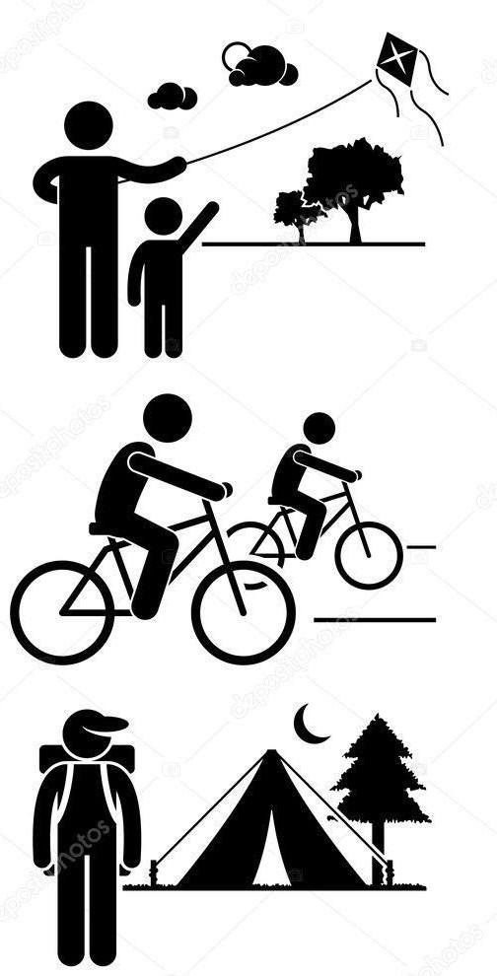
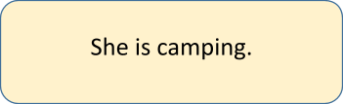
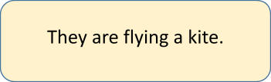
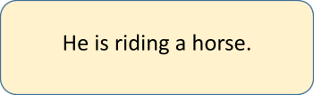
Name: Surname: N^{ber}: Grade/Class:
Assessment: | Date:
 | Teacher’s signature: | Parent’s signature:

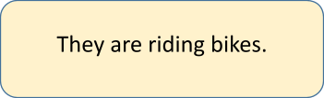
1. Read and match.
Answer key

