Name: ____________________________ Surname: ____________________________ N^{ber}: ____ Grade/Class: _____
Assessment: _____________________________ | Date: ___________________________________________________
 | Teacher’s signature:  ___________________________ | Parent’s signature:  ___________________________

1.Look at the pictures. What do they like? Tell and listen to your partner and fill in the blanks. (Student A)
Example : “She likes playing football.”
 | 2. ......................... | 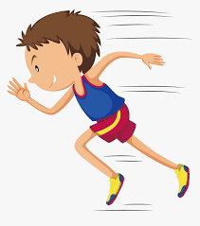 | 4. .........................
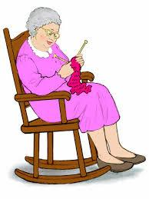 | 6. ............................ |  | 8. .........................
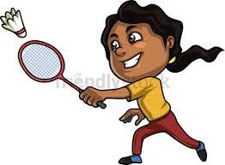 | 10. ........................... | 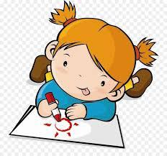 | 12. .........................

- Look at the pictures. What are they doing? Tell and listen to your partner and fill in the blanks. (Student B)

1………………………… |  | 3............................
5............................. | 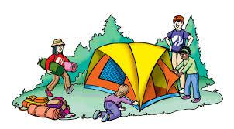 | 7……………………………. | 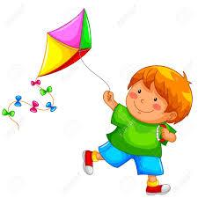
9………………………… | 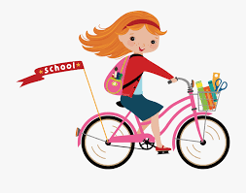 | 11…………………………. | 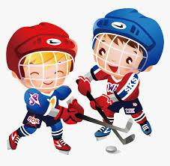

Answer key
- She likes swimming
- She likes dancing
- He likes running
- He likes playing computer games
- She likes knitting
- They like camping
- She likes reading
- He likes flying a kite
- She likes playing badminton
- She likes riding a bike
- She likes drawing
- They like playing hockey

