Name: ____________________________ Surname: ____________________________ N^{ber}: ____ Grade/Class: _____
Assessment: _____________________________  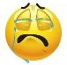  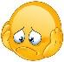  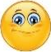 | Date: ___________________________________________________
 | Teacher’s signature:  ___________________________ | Parent’s signature:  ___________________________

- Look at the pictures and make sentences.
= like / likes 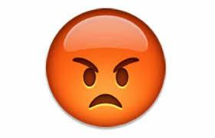 = don’t like / doesn’t like
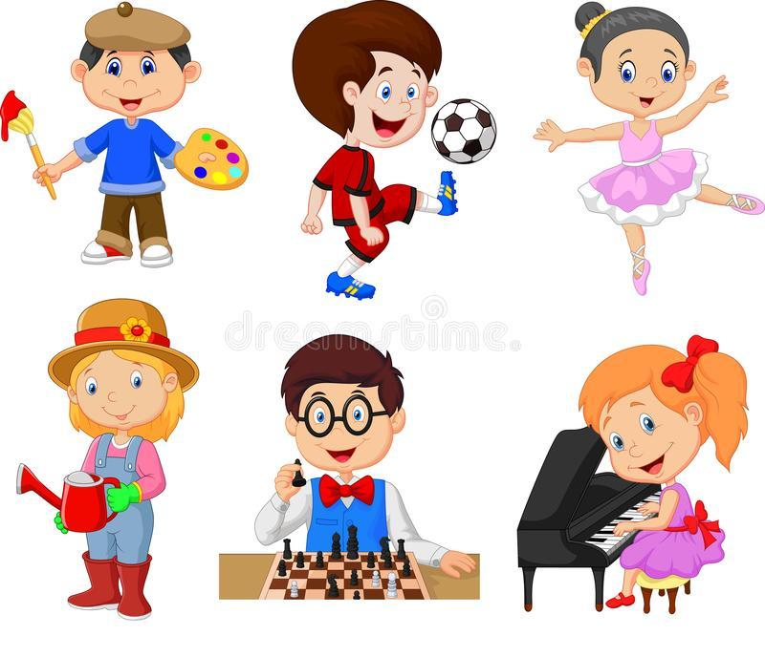

- What is your favorite hobby?

Answer key
He doesn’t like painting.
He likes playing football.
She doesn’t like dancing.
She likes gardening.
He likes playing chess.
She doesn’t like playing the piano.

