Name: ____________________________ Surname: ____________________________ N^{ber}: ____ Grade/Class: _____
Assessment: _____________________________ | Date: ___________________________________________________
 | Teacher’s signature:  ___________________________ | Parent’s signature:  ___________________________

- Look at the table and make sentences.
 | Swimming | Visiting a museum | Collecting coins | Playing hopscotch | Going to the beach | Watching cartoons | Playing the piano
I
Tom
Eva
Tina
Feri
Lizzy
Gina and Amy

Example: I like swimming and ..., I don’t like collecting stamps and...
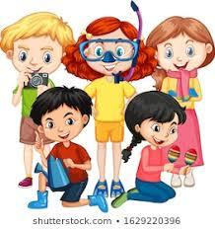

Answer key

 | Swimming | Visiting museums | Collecting coins | Playing hopscotch | Going to the beach | Watching cartoons | Playing the piano
I
Tom
Eva
Tina
Feri
Lizzy
Gina and Amy

I like swimming and going to the beach, I don’t like collecting stamps and playing hopscotch.
Tom likes visiting museums and playing the piano, he doesn’t like swimming and watching cartoons.
Eva likes collecting coins and playing hopscotch, she doesn’t like visiting museums and playing the piano.
Tina likes visiting museums and playing the piano, she doesn’t like playing hopscotch and watching cartoons.
Feri likes going to the beach and watching cartoons, she doesn’t like collecting stamps and playing the piano.
Lizzy likes swimming and playing hopscotch, she doesn’t like visiting museums and going to the beach.
Gina and Amy like collecting stamps and watching cartoons, they don’t like swimming and going to the beach.

