Name: ____________________________ Surname: ____________________________ N^{ber}: ____ Grade/Class: _____
Assessment: _____________________________  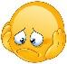 | Date: ___________________________________________________
 | Teacher’s signature:  ___________________________ | Parent’s signature:  ___________________________
- Look at the pictures and fill in the blanks.
= like =love = don’t like = hate
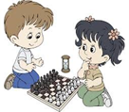

I ……………………… .....................

She ……………………… dancing.

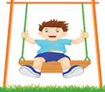
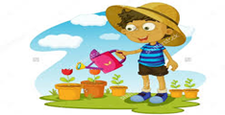

He ……………………… ....................

He ……………………… ...................

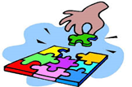
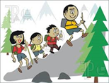

She ……………………… ....................

They ……………………… ...............

Answer key

I like playing chess.

She loves dancing.

He loves swinging.

He doesn’t like gardening.

She hates doing puzzle.

They don’t like hiking.

