Name: ____________________________ Surname: ____________________________ N^{ber}: ____ Grade/Class: _____
Assessment: _____________________________  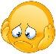 | Date: ___________________________________________________
 | Teacher’s signature:  ___________________________ | Parent’s signature:  ___________________________

- Look and match.

Flying a kite

Watching cartoons
Riding a bike
Surfing the net
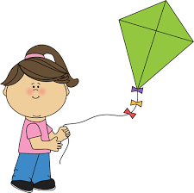
Doing puzzle

Collecting things

Answer key
Flying a kite
Watching cartoons
Riding a bike
Surfing the net
Doing puzzle

Collecting things

