Name: ____________________________ Surname: ____________________________ N^{ber}: ____ Grade/Class: _____
Assessment: _____________________________  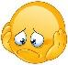 | Date: ___________________________________________________
 | Teacher’s signature:  ___________________________ | Parent’s signature:  ___________________________

- Find the words in the puzzle.
FLY PLAY GOLF SING DRAW WRITE
READ SWIM SKI DANCE RIDE A BIKE

- Look and complete.
Riding a _____________ 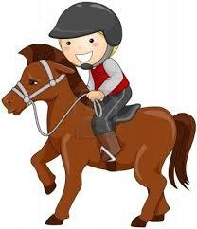 Going to the ___________
Doing a _____________ 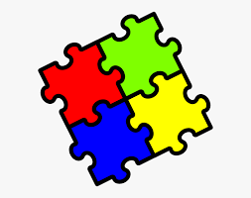 Visiting ___________ 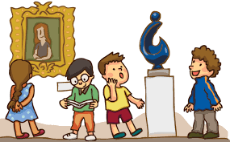
Playing _____________ Talking with __________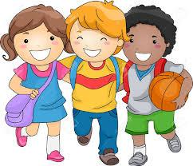

Answer key

Riding a horse Going to the theatre
Doing a puzzle Visiting museums
Playing bowling Talking with friends

