Name: ____________________________ Surname: ____________________________ N^{ber}: ____ Grade/Class: _____
Assessment: _____________________________  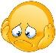 | Date: ___________________________________________________
 | Teacher’s signature:  ___________________________ | Parent’s signature:  ___________________________

- Write the name of the hobbies.
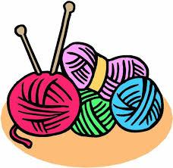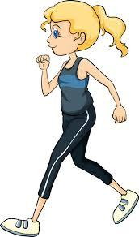

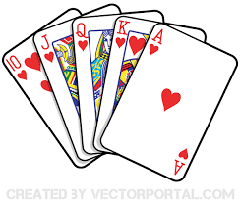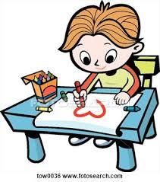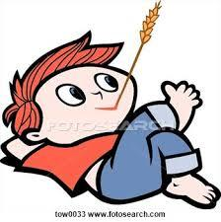

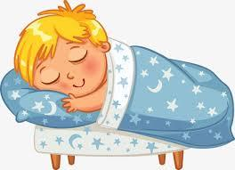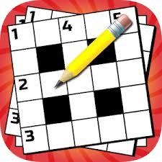

Answer key
writing
walking / running
knitting

playing cards
relaxing
drawing

sleeping
performing
doing crosswords

