Name: ____________________________ Surname: ____________________________ N^{ber}: ____ Grade/Class: _____
Assessment: _____________________________ | Date: ___________________________________________________
 | Teacher’s signature:  ___________________________ | Parent’s signature:  ___________________________

- Look and write what they like and don’t like.

They like ______________.
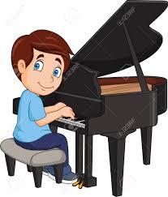
_________________.
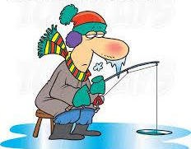

He doesn’t like _______.

___________________.

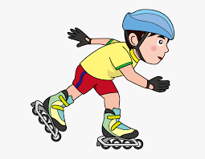
___________________.

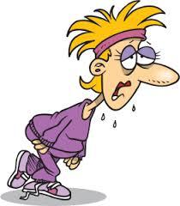
___________________.

Answer key

They like going to the cinema.
He likes playing the piano
He doesn’t like fishing.
He likes reading.
He likes skating.
She doesn’t like running.

