Name: ____________________________ Surname: ____________________________ N^{ber}: ____ Grade/Class: _____
Assessment: _____________________________ | Date: ___________________________________________________
 | Teacher’s signature:  ___________________________ | Parent’s signature:  ___________________________

- Write the activities Sal likes, or doesn’t like.

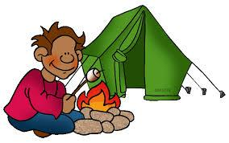

- _______________________________________________________.
- _______________________________________________________.
- _______________________________________________________.
- _______________________________________________________.
- _______________________________________________________.
- _______________________________________________________.

Answer key
- He likes playing yoyo.
- He likes sleeping.
- He likes playing chess.
- He likes drawing.
- He doesn’t like camping.
- He doesn’t like flying a kite.

