Name: ____________________________ Surname: ____________________________ N^{ber}: ____ Grade/Class: _____
Assessment: _____________________________ | Date: ___________________________________________________
 | Teacher’s signature:  ___________________________ | Parent’s signature:  ___________________________

- Read and correct the mistakes.
rowing fishing camping visiting museums
shopping swimming playing volleyball hiking

We go on summer holiday with my family in August. We like going __________ 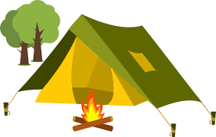 . On sunny days, I like __________ 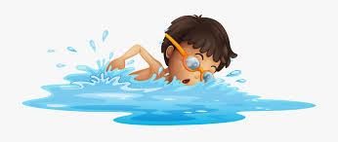. My sister and mom like ____________ ___________ 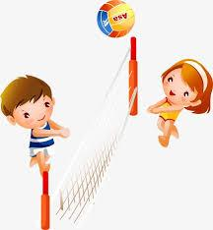 . And my father and my brother like ___________ 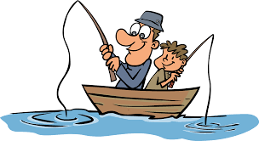and _______________ . On cloudy days, we like ____________ 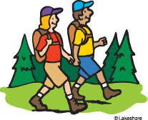. We don’t like ___________ on holiday. But we love ____________ ___________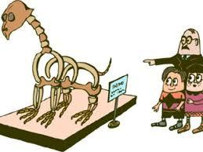 in the city center. How is your

holiday?

Answer key
We go on summer holiday with my family in August. We like going camping . On sunny days, I like swimming . My sister and mom like playing volleyball and my father and my brother like fishing and rowing . On cloudy days, we like hiking . We don’t like shopping in holiday but we love visiting museums in

the city center. How is your holiday?

