Name: ____________________________ Surname: ____________________________ N^{ber}: ____ Grade/Class: _____
Assessment: _____________________________  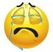  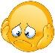  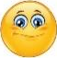  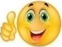 | Date: ___________________________________________________
 | Teacher’s signature:  ___________________________ | Parent’s signature:  ___________________________

- Read and correct the mistakes.
I like playing basketball. I like cooking. I like doing puzzle.
I like playing basketball. I like cooking. I like doing puzzle.
I like playing basketball. I like cooking. I like doing puzzle.
I like singing. I like surfing the net. I like collecting stamps.

Answer key
Read and correct the mistakes.

I like playing badminton. I like skating. I like surfing the
I like playing basketball. I like cooking. I like doing puzzle.
I like riding bike. I like reading. I like listening to music.
I like painting/drawing. I like playing football. I like taking photograph.

