Name: ____________________________ Surname: ____________________________ N^{ber}: ____ Grade/Class: _____
Assessment: _____________________________ | Date: ___________________________________________________
 | Teacher’s signature:  ___________________________ | Parent’s signature:  ___________________________
- Look at the pictures and make sentences. “They love walking.”
= like = love = don’t like = hate
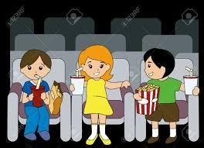

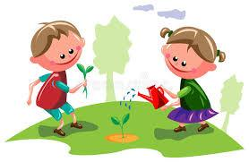
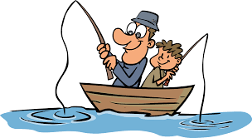
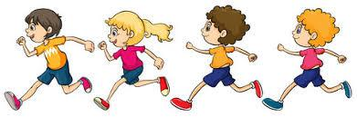

Answer key

They love going to the cinema
He hates coloring books / drawing
They like gardening.
He doesn’t like studying
He hates walking.
They love fishing.
He likes relaxing.
They don’t like running.

