Name: ____________________________ Surname: ____________________________ N^{ber}: ____ Grade/Class: _____
Assessment: _____________________________  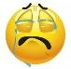  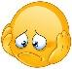  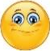  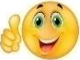 | Date: ___________________________________________________
 | Teacher’s signature:  ___________________________ | Parent’s signature:  ___________________________

- Look at the pictures. Mime them to your partner. S/he will guess. (Student A)

- Now it is your turn. Watch your partner. Try to guess which free time activity she is trying to explain.

...

- Watch your partner. Try to guess which free time activity she is trying to explain. (Student B)

...

- Now it’s your turn. Look at the pictures. Mime them to your partner. S/he will guess.

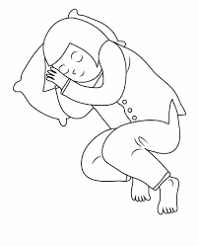

Answer key

Student A
swimming
singing
reading
skipping a rope
running
drawing
playing chess
dancing

Student B
swinging
playing marbles
sleeping
watching cartoon/TV
playing table tennis
riding a bike
playing hopscotch
painting

