Name: ____________________________ Surname: ____________________________ N^{ber}: ____ Grade/Class: _____
Assessment: _____________________________ | Date: ___________________________________________________
 | Teacher’s signature:  ___________________________ | Parent’s signature:  ___________________________

- Look at the pictures, read and tell.

= like = don’t like / doesn’t like = love = hate
Paul
study
play computer games
hike
sleep

Kelly
watch TV
read books
play tennis
paint
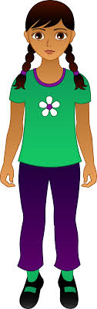

Lucky
run
play hide and seek
relax
swim
Ray and Mary
take photos
walk
dance
camp
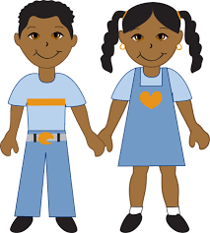

Answer key
Kelly likes reading books.
Kelly loves painting.
Kelly doesn’t like playing tennis.
Kelly hates watching TV.

Paul likes studying.
Paul loves hiking.
Paul doesn’t like playing computer games.
Paul hates sleeping.

Ray and Mary like camping.
Ray and Mary love dancing.
Ray and Mary doesn’t like taking photos.
Ray and Mary hates walking.

Lucky likes running.
Lucky loves playing hide and seek.
Lucky doesn’t like relaxing.
Lucky hates swimming.

