Name: ____________________________ Surname: ____________________________ N^{ber}: ____ Grade/Class: _____
Assessment: _____________________________  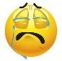  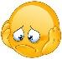 | Date: ___________________________________________________
 | Teacher’s signature:  ___________________________ | Parent’s signature:  ___________________________

- Look at the pictures and answer the questions.
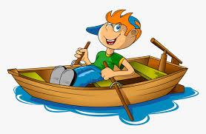
What’s his favorite hobby? What’s their favorite hobby?
______________________ ______________________
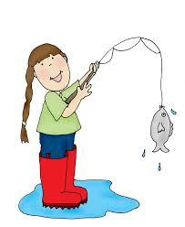
What’s her favorite hobby? What’s her favorite hobby?
__________________________ __________________________

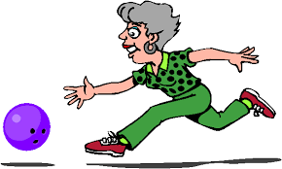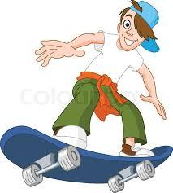
What’s her favorite hobby? What’s his favorite hobby?
__________________________ __________________________

Answer key
- Look at the pictures and answer the questions.

What’s his favorite hobby? What’s their favorite hobby?
It’s rowing It’s cooking
What’s her favorite hobby? What’s her favorite hobby?
It’s fishing It’s listening to music

What’s her favorite hobby? What’s his favorite hobby?
It’s playing bowling It’s skating

