|  |  |  |
| --- | --- | --- |
| **Name:** ____________________________ **Surname:** ____________________________ **Nber: ____ Grade/Class:** _____ | | |
| **Assessment:** _____________________________ | **Date:** ___________________________________________________ | |
| **Teacher’s signature:**  **___________________________** | **Parent’s signature:**  **___________________________** |

**1.** **Write *like, don’t like, likes* or *doesn’t like.***

☹ **a**. I -------------- music. ☺ **e**. He--------------dolphins.

☺ **b**. He ----------chocolate ☹ **f**. She --------------------fish.

☺ **c**. They--------------cars. ☺ **g**. They--------------English.

☹ **d**. She-----------cats. ☹ **h**. I-------------cold weather.

**2. Write the names of the activities.**



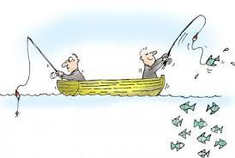 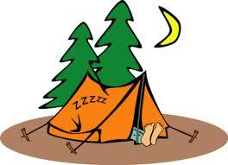 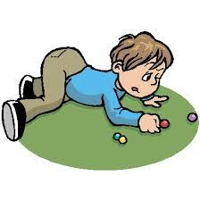

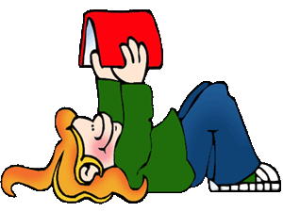

a…………………… b…………………………… c………………………… d………………………………

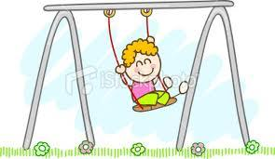 

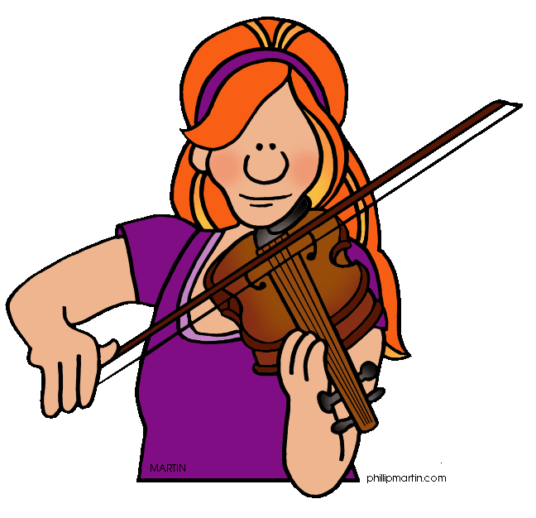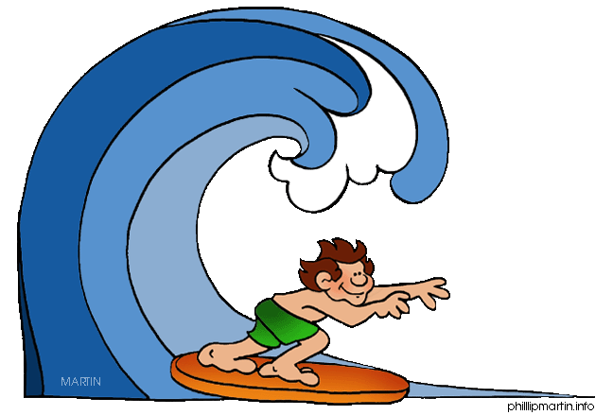

e……………………………… f…………………… g…………………………… h…………………………

i……………………… j………………………… k…………………… l……………………………

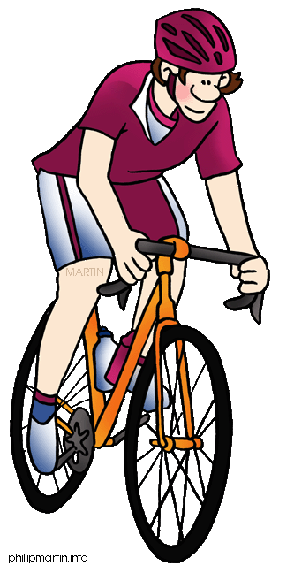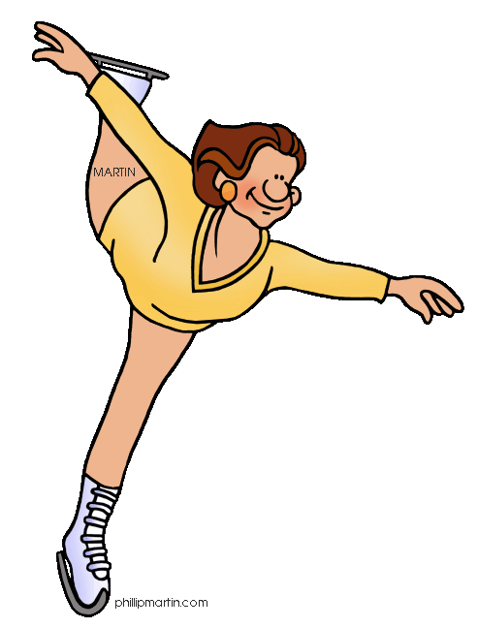

**Answer key**

☹ **1**. I don’t like music. ☺ **5**. He likes dolphins.

☺ **2**. He likes chocolate ☹ **6**.She doesn’t like fish.

☺ **3**. They like cars. ☺ **7**.They like English.

☹ **4**. She doesn’t like cats. ☹ **8**. I don’t like cold weather.

**2.**

  



1 fishing 2 reading 3 camping 4 playing marbles

 



5 swinging 6 painting 7 playing the violin 8 surfing



9 playing computer games 10 riding a bike 11 ice-skating 12 sending an e-mail